Business Request Intake and Reporting Automation

Functional Specifications Document

1.Document Purpose:
This document defines the functional requirements for a prototype business request intake and reporting workflow. The solution is designed to replace unstructured request collection through emails, messages and spreadsheets with a centralized and automated process using Microsoft Forms, Power Automate, SharePoint, Outlook, Gemini API and Power BI.
The document describes the current process, proposed workflow, user requirements, business rules, functional requirements and acceptance criteria for the system.

2.Business Problem:
Business requests such as reporting requirements, project requests, process-improvement suggestions and operational changes are often received through multiple channels. This makes it difficult to track requests consistently, identify urgent items, communicate status updates and prepare management reports.
The existing manual process may result in incomplete information, delayed responses, duplicate requests, missed deadlines and limited visibility into the overall request pipeline.

3.Project Objective:
The objective of this project is to design and build a centralized workflow that captures business requests, stores them in a structured register, sends automatic confirmation messages, identifies high-priority submissions and provides reporting through an AI-generated weekly summary and a Power BI dashboard.

- Standardize the request-submission process.
- Reduce manual data entry and email follow-ups.
- Maintain a centralized and auditable request register.
- Automatically identify and escalate urgent requests.
- Improve visibility through management summaries and dashboards.
- Demonstrate the integration of Microsoft 365 tools with AI-assisted reporting.

4.Project Scope:
4.1 In Scope :
- Business request submission through Microsoft Forms
- Automated data transfer to a SharePoint list
- Automatic confirmation email to the requester
- Priority-based email alerts
- Request status and deadline tracking
- Weekly AI-generated request summary
- Power BI dashboard for request monitoring
- Basic workflow testing and acceptance criteria
4.2 Out Of Scope:
- Production deployment within a real organization
- Integration with confidential company systems
- Automatic approval of business requests
- Advanced user-access controls
- Financial transaction processing
- Enterprise security and compliance configuration
- Automatic assignment of requests to employees

5.Stakeholder:
Stakeholder | Responsibility
Requester | Submits the business request and receives confirmation
Business Analyst or Coordinator | Reviews, categorizes and tracks submitted requests
Request Owner | Works on the assigned request and updates its status
Management | Reviews priorities, deadlines and weekly reporting
System Administrator | Maintains the Microsoft 365 environment and workflow connections
6.Current Process – As Is
- A requester communicates a business need through email, chat or another informal channel.
- The coordinator manually reviews the request.
- The request details are copied into a spreadsheet or personal tracking document.
- The request details are copied into a spreadsheet or personal tracking document.
- Urgent requests are identified manually.
- Confirmation and status updates are sent separately.
- Weekly reports are manually prepared by reviewing multiple records.

- Current Process Problems :
Problem | Business Impact
Requests arrive through different channels | Information becomes fragmented
No standard request format | Important details may be missing
Manual data entry | Increased processing time and error risk
No automatic priority escalation | Urgent requests may be overlooked
Spreadsheet-based tracking | Limited auditability and visibility
Manual reporting | Repetitive work and inconsistent summaries

7.Proposed Process – To Be
- The requester submits a standardized Microsoft Form.
- Power Automate retrieves the submitted response.
- The request is recorded in a SharePoint list.
- SharePoint generates a unique request ID.
- The requester receives an automatic confirmation email.
- High- or critical-priority requests generate an escalation email.
- Request status, owner and deadline are maintained in SharePoint.
- A scheduled workflow retrieves active requests each week.
- Gemini API generates a structured management summary.
- Power BI displays request status, category, priority and deadline information.

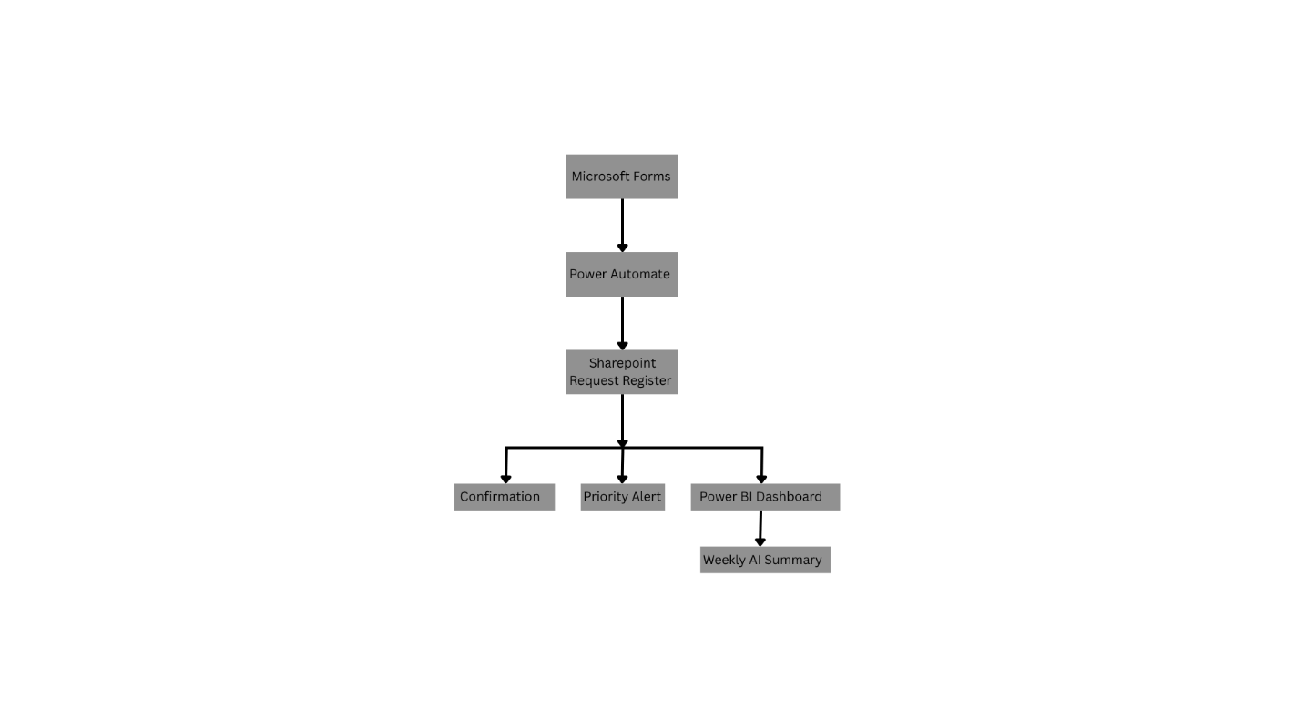

8.Functional Requirements :
ID | Functional Requirement | Priority
FR-01 | The system shall allow users to submit a business request through Microsoft Forms. | Must Have
FR-02 | The system shall require mandatory request information before submission. | Must Have
FR-03 | The system shall create a SharePoint list item for every valid form submission. | Must Have
FR-04 | The system shall generate a unique request ID using the SharePoint item ID. | Must Have
FR-05 | The system shall send an automatic confirmation email to the requester. | Must Have
FR-06 | The system shall assign the default status “Submitted” to new requests. | Must Have
FR-07 | The system shall send an escalation email for High and Critical requests. | Must Have
FR-08 | Authorized users shall be able to update request status, owner and completion date. | Should Have
FR-09 | The system shall retrieve active requests on a weekly schedule. | Should Have
FR-10 | The system shall generate a structured AI-assisted weekly summary. | Should Have
FR-11 | The AI summary shall not invent missing data. | Must Have
FR-12 | Power BI shall display request volume, category, priority, status and deadline information. | Should Have
FR-13 | Completed requests shall be excluded from the active weekly summary. | Should Have
FR-14 | SharePoint version history shall maintain a record of request updates. | Could Have

9.Business Rules :
- BR-01: Every new request shall receive the status “Submitted.”
- BR-02: Requester name, email, request title, business need, priority and target date are mandatory.
- BR-03: High and Critical requests shall generate an escalation notification.
- BR-04: Only active requests shall be included in the weekly management summary.
- BR-05: Requests with a target date earlier than the current date and a non-completed status shall be considered overdue.
- BR-06: The AI-generated summary shall use only the data retrieved from SharePoint.
- BR-07: Missing information shall be identified as unavailable rather than inferred.
- BR-08: AI-generated content shall be reviewed before being used for decision-making.

10.Data Fields :

Field | Type | Required | Description
Request ID | Number | Automatic | Unique SharePoint-generated identifier
Request Title | Text | Yes | Short name of the request
Requester Name | Text | Yes | Name of the submitting user
Requester Email | Text | Yes | Email used for confirmation
Business Unit | Choice | Yes | Department submitting the request
Request Type | Choice | Yes | Project, Reporting, Change Request, Process Improvement or Other
Business Need | Long text | Yes | Detailed explanation of the request
Expected Benefit | Long text | No | Expected business outcome
Priority | Choice | Yes | Low, Medium, High or Critical
Target Date | Date | Yes | Required completion date
Status | Choice | Automatic | Submitted, Under Review, In Progress, Completed or Rejected
Owner | Text | No | Person responsible for the request
Date Submitted | Date and time | Automatic | Date on which the request was received
Completion Date | Date | No | Date on which the request was completed
AI Summary | Long text | No | Optional generated summary

11.Acceptance Criteria:

ID | Test Scenario | Expected Result
AC-01 | User submits a valid request | A SharePoint item is created
AC-02 | User submits a request | Confirmation email is received
AC-03 | User submits a Critical request | Escalation email is generated
AC-04 | User leaves a mandatory field blank | Form prevents submission
AC-05 | Weekly flow is triggered | Active requests are retrieved
AC-06 | Completed request exists | It is excluded from the active-request digest
AC-07 | Request has missing owner | AI summary identifies the owner as unavailable
AC-08 | SharePoint data is refreshed in Power BI | Dashboard reflects the latest records

12.Success Measures:
Metric | Measurement Method
Request logging time | Compare manual entry with automated submission
Confirmation time | Measure form submission to email receipt
Reporting preparation time | Compare manual summary creation with automated digest
Data completeness | Check mandatory fields across test submissions
Priority identification | Confirm that all High and Critical requests trigger alerts
Workflow reliability | Percentage of successful test runs

